**Computational Modelling and Simulation**

**‘Damped Harmonic Oscillator Analysis’**

**FIT3139 Assignment 1**

**Harvey Houlahan**

**33970076**

**20/03/2025**

**1). EXACT SOLUTION**

**Graph 1: Exact Damped Oscillator – Varying 𝛾 (with 𝜔 = 1.0)
**

**Description:** *This graph shows the exact solution:*

$$θ\left(t\right)=θ_{0} e^{-γt} ​cos(\sqrt{1-γ^{2}}​t)$$

*for three values of the damping coefficient $γ$ (0.1, 0.5, and 0.9), with*

$θ_{0}=1$*and $ω=1.0$*

***Graph 1: Exact Damped Oscillator – Varying 𝛾 (with 𝜔 = 1.0)***

**Mathematical Analysis:**

* The exponential decay term $e^{-γt}$ dictates how rapidly the amplitude decreases. For γ = 0.1, the decay is slow, so the oscillations remain visible over a longer period. Conversely, for γ = 0.9, the envelope decays much faster.
* The effective oscillation frequency is given by $Ω = \sqrt{1-γ^{2}}$. For example:
  + For $γ=0.1: Ω≈\sqrt{0.99}≈0.995$
  + For $γ=0.5: Ω≈\sqrt{0.75}≈0.866$
  + For $γ=0.9: Ω≈\sqrt{0.19}≈0.436$

Therefore, it can be observed that an increasing γ not only accelerates decay but also reduces the oscillation frequency. The phase and amplitude behaviour are directly controlled by these two factors, which is evident in the spacing and damping of the curves.

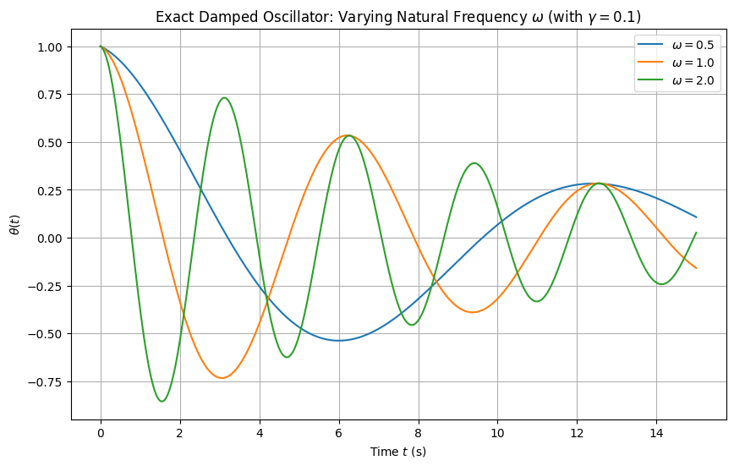

**Description:** *This graph shows the exact solution* for three values of ω *(0.5, 1.0, and 2.0) while keeping $γ=0.1$*  *and $θ_{0}=1.0$ constant.*

***Graph 2: Exact Damped Oscillator – Varying 𝜔 (with 𝛾 = 0.1)***

**Mathematical Analysis:**

* The effective frequency is $Ω=\sqrt{ω^{2}-γ^{2}}​$. As $ω$ increases, $Ω$ increases:
  + For $ω=0.5: Ω≈\sqrt{0.25-0.01}≈0.490$
  + For $ω=1.0: Ω≈\sqrt{1-0.01}≈0.995$
  + For $ω=2.0: Ω≈\sqrt{2-0.01}≈1.997$
* The oscillation period $T$ is $T=\frac{2π}{Ω}$. Thus, with increasing $ω$, the period shortens:
  + $T≈\frac{2π}{0.490} ≈12.8$ for $ω=0.5$,
  + $T≈\frac{2π}{0.995} ≈6.3$ for $ω=1.0$,
  + $T≈\frac{2π}{1.997} ≈3.1$ for $ω=2.0$
* The function observes $e^{-0.1t}$ decay.

Thus, while the decay rate is unchanged, increasing $ω$ compresses the oscillatory cycles, making the function oscillate more rapidly.

**2). MODELLING ERRORS**

***Description:*** *The function is approximated through truncating the Taylor Series expansion to the first two nonzero terms:*

$$θ_{approx}\left(t\right)=θ_{0}(1-γt)$$

*for various $γ$ values (0.1, 0.5, 0.9).*

***Graph 3: Taylor Series Approximation – Varying $γ$.***

**Mathematical Analysis:**

* The approximation comes from:
  + $e^{-γt}≈1-γt$, and
$\cos\left(\sqrt{ω^{2}-γ^{2}}t\right)≈1$

* The approximation is linear with derivative $-θ_{0}​γ$ and is valid only for small $t$.
  + At $γ=0.1$, the function decreases slowly.
  + Comparatively, at $γ=0.9$, the function decreases more rapidly, intersecting the x-axis at $t=1/γ$.

This graph mathematically demonstrates that the approximation, while capturing the initial slope, fails to model the curvature and oscillations of the true function.

**Description:** The graph plots $θ_{approx}\left(t\right)=θ_{0}(1-γt)$ for different $ω$ values while keeping $γ=0.1$. ***Graph 4: Taylor Series Approximation – Varying $ω$ (with $γ=0.1$)***

**Mathematical Analysis:**

* Notice that the approximation does not include ω; therefore, regardless of the value of ω, the function remains the same.
* Mathematically, the cosine expansion is truncated to 1, so all ω-dependent terms (which appear in higher-order terms, starting at $t^{2}$ are omitted.
* This emphasizes that the two-term Taylor approximation cannot capture changes in oscillatory behaviour resulting in all curves collapsing into a single line.

**3). DATA ERRORS**

***Description:*** *This graph compares the exact solution with the same solution computed using 3-decimal chopping for $γ=0.1, 0.5, 0.9$.*

***Graph 5: Exact vs. Chopped (3-decimal) – Varying $γ$***

**Mathematical Analysis:**

* The exact function is computed using full-precision arithmetic, while the chopped version truncates all intermediate computations to 3 decimal places.
* The results show that the numerical error introduced by chopping is on the order of ${10}^{-3}$ relative to the function's values, which is negligible when compared to the overall amplitude.
* The minor differences (if any) indicate that the damped oscillator function is robust to this level of rounding error within the domain considered.

***Description:*** *Similar to Graph 5, this graph shows the exact solution versus the chopped solution for varying $ω (0.5, 1.0, 2.0)$ while $γ=0.1$.*

***Graph 6: Exact vs. Chopped (3-decimal) – Varying $ω$ (with $γ=0.1$)***

**Mathematical Analysis:**

* The effect of chopping is again minimal, and the curves for the chopped solution lie almost perfectly over those for the exact solution.
* This confirms that for the parameters and domain chosen, the truncation error from limiting precision to three decimal places does not significantly alter the oscillatory behaviour or the decay envelope.
* Thus, the numerical method is stable with respect to this rounding when using full function evaluation.

**4). TOTAL ERROR**

***Description:*** *This graph compares the exact solution with the Taylor series approximation that is also computed using 3-decimal chopping, for $γ=0.5$* and $ω=1.0$.

**Mathematical Analysis:**

* At $t=0$, both the exact and approximate functions approximate (since $θ(0)=θ_{0}$).
* As $t$ increases, the exact function continues to oscillate with a decaying envelope $e^{-0.5t}cos(\sqrt{1-0.25​t})$, whereas the approximation $θ_{approx}$